**WORKFLOW DESIGN (STAGES-CREATE)**

|  |  |
| --- | --- |
| **Use Case ID** | ADV-WFD-SC-UC-01 |
| **Use Case Name** | WORKFLOW DESIGN STAGES |
| **Actors** | Super User |
| **Description** | The process involves creating and configuring stages within a workflow design. |
| **Pre-Condition** | The user should be able to login with valid credentials |
| **Post Condition** | A new stage is successfully created and configured within the workflow |
| **Created On** | 8/07/2024 |
| **Created By** | Patil Bhuvaneshwari |
| **Reviewer** | Nayagam |
| **Version** | 2.0 |

**STAGES (CREATE)**

**UC-1 Stages (Create)**

**UC-1.1:** Click on "**Workflow Design**".

**UC-1.2**: Click on "**Stages**".

(Located on the top right corner)

**UC-1.3**: Click on the "**Create**" button.

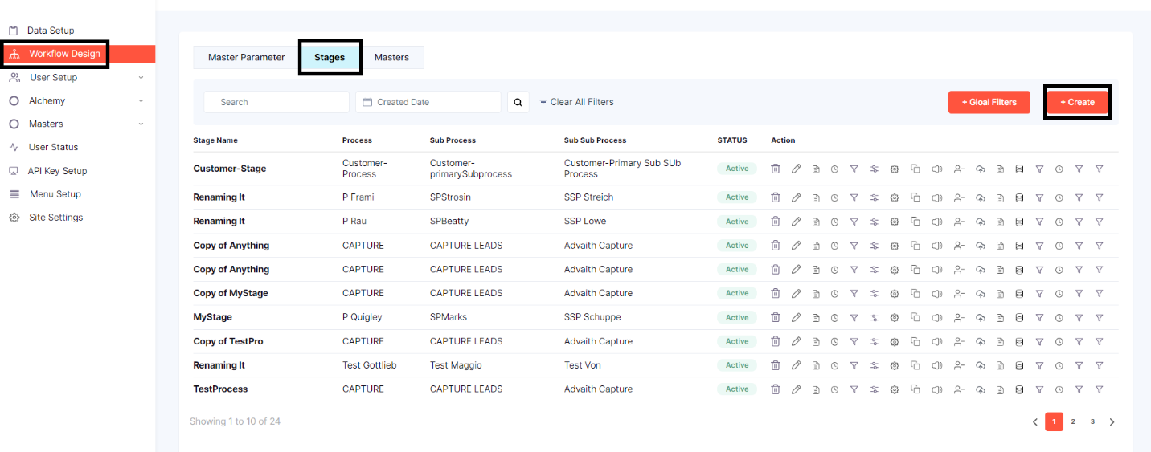

The form to be filled will pop up

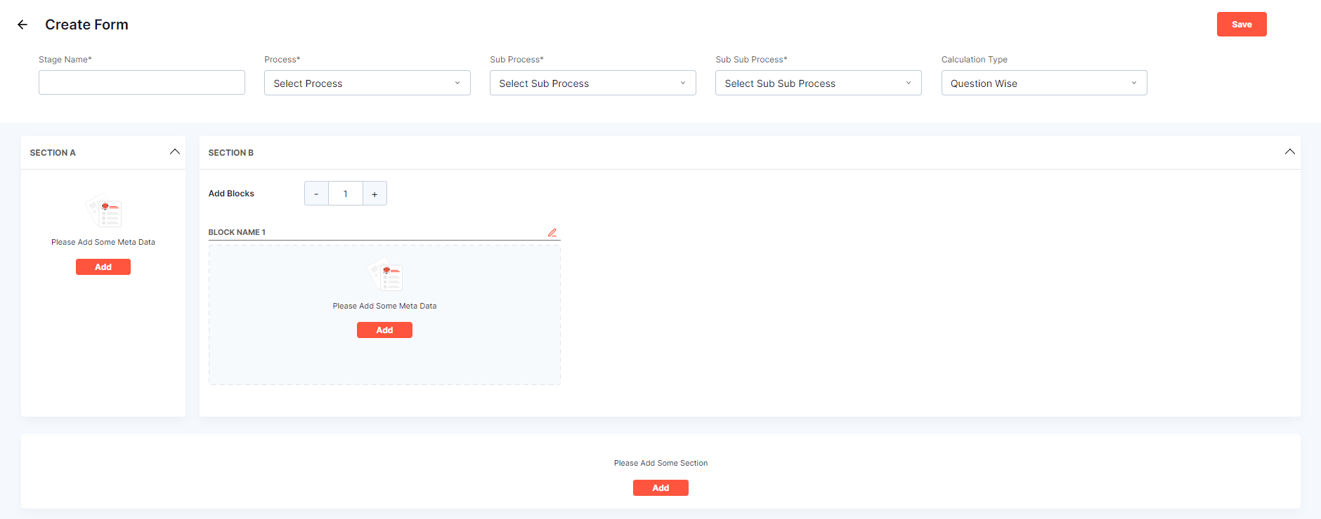 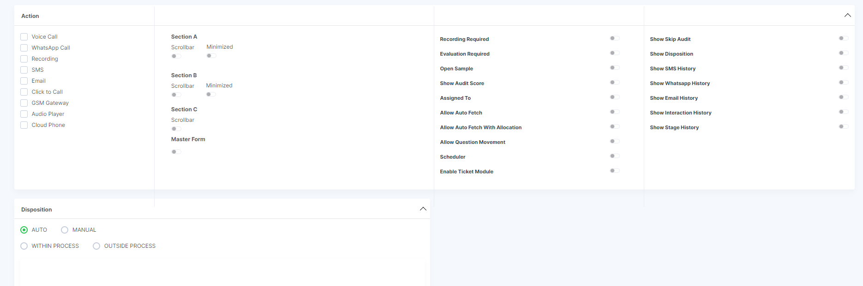

**UC-1.4:** PROCESS SELECTION



* **UC-1.4.1: Stage Name**: Enter the name of the stage for which you are creating the form.
* **UC-1.4.2: Process**: Select the relevant process from the dropdown menu.
* **UC-1.4.3: Sub Process**: Choose the sub-process from the dropdown menu.
* **UC-1.4.4: Sub Sub Process**: Select the sub-sub process from the dropdown menu.
* **UC-1.4.5: Calculation Type**: Choose the calculation type (e.g., Question Wise, Parameter wise, Domain wise)

**UC-1.5**: Configuring Sections

**UC-1.5.1**: Section A

* **UC-1.5.1(a):** Click on the **Add** button

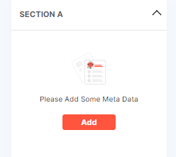

* **UC-1.5.1(b):** A tab will open user needs to select the Metadata from the dropdown menu. Before selecting the Metadata user needs to make sure that the unique fields are marked in the “**Metadata”** section under “**Data Setup”.**

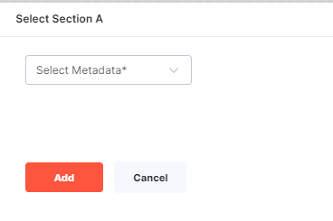

* **UC-1.5.1(c):** Once the user selects the Metadata, List of options with check box will show up select the desired checkboxes

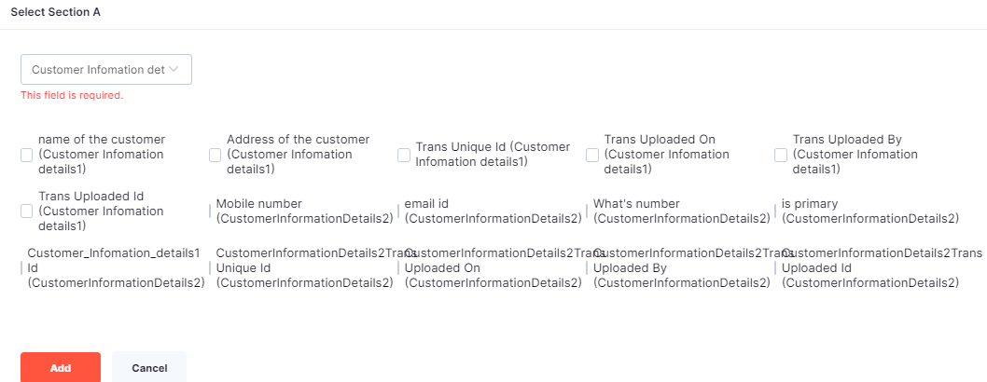

* **UC-1.5.1(d):** Click on the **Add** button.
* **UC-1.5.1(e):** The selected checkbox options will be displayed in Section A.
* **UC-1.5.1(f):** To edit the selected options, click on the **Edit** button.

**UC-1.5.2**: Section B

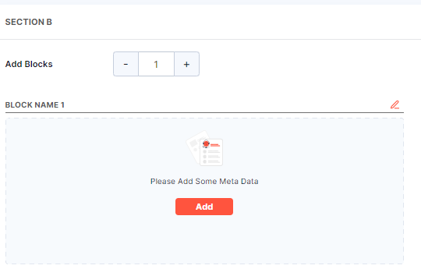

* **1.5.2(a): Add Blocks**: Use the “–“and “+” buttons to adjust the number of blocks.
* **1.5.2(b):** For each block, click on the **Add** button to add metadata.

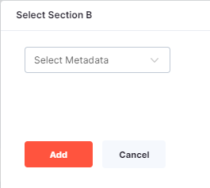

* **1.5.2(c):** Select the Metadata information from the dropdown menu.
* **1.5.2(d):** Once the user selects the Metadata, List of options with check box will show up select the desired checkboxes.

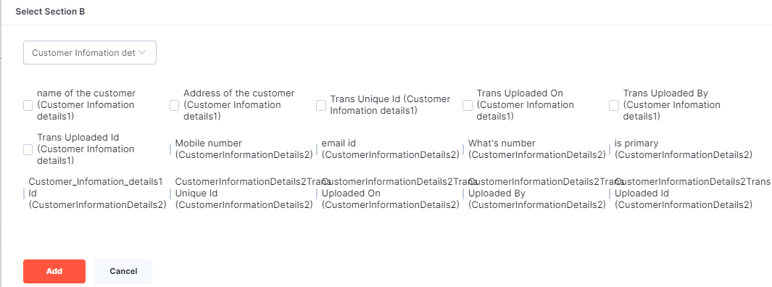

* **1.5.2(e):** Click on the **Add** button.
* **1.5.2(f):** The selected checkbox options will be displayed in the Block.
* **1.5.2(g):** To edit the selected options, click on the **Edit** button.

**UC-1.5.3:** Additional Section

User has an option to add a New Section.

**UC-1.5.3(a):** Click on **Add** button.

A window will open with Add Section Form

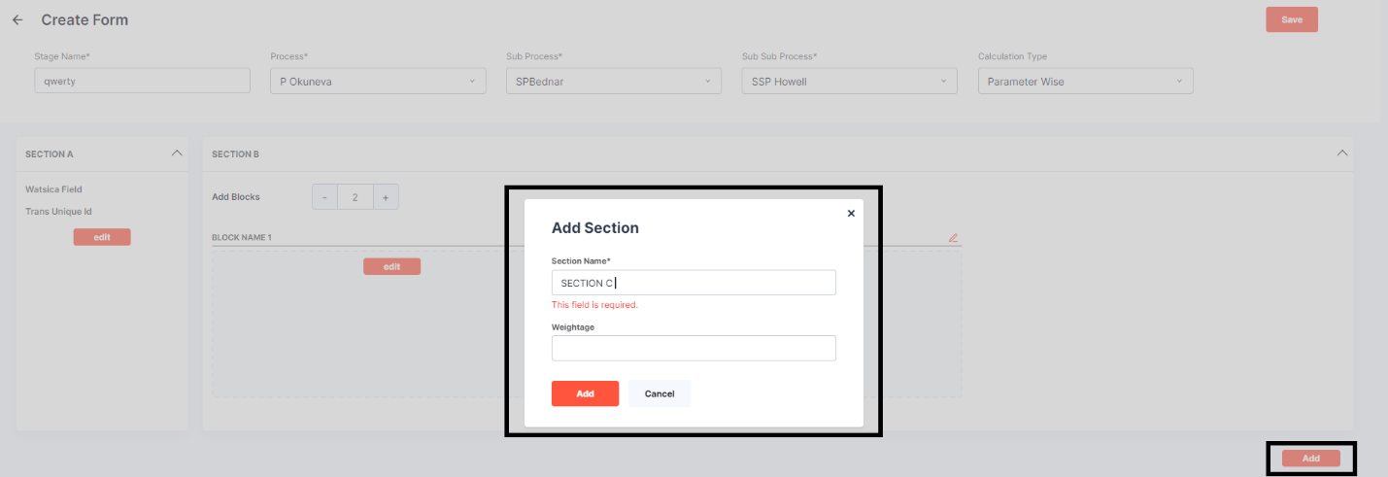

* **UC-1.5.3(b): Section Name**: Name the section in the text box field it is a mandatory field.
* **UC-1.5.3(c): Weightage**: Optional field
* **UC-1.5.3(d): Add**: Click on “**Add**” to add the section.
* **UC-1.5.3(e): Cancel**: “**Cancel**” it if it is not required.

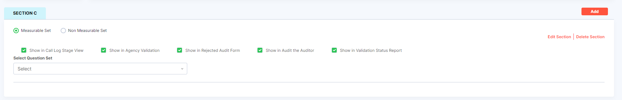

**UC-1.5.3(f):** Click on the created section. Once the section is added it is shown under the section A

**UC-1.5.3(g)**: Select whether the section is a **Measurable set** or a **non-Measurable set**.

* **Show in Call Log Stage View**: Toggle this option to display in the call log stage view.
* **Show in Agency Validation**: Toggle this option to display in agency validation.
* **Show in Rejected Audit Form**: Toggle this option to display in the rejected audit form.
* **Show in Audit the Auditor**: Toggle this option to display in the auditor's audit.
* **Show in Validation Status Report**: Toggle this option to display in the validation status report.

**UC-1.5.3(h):** Choose the relevant **Question set** from the dropdown menu. Whichever question set is selected that will be displayed below

* **UC-1.5.3(i):** Click on **Edit Section** to modify an existing section.
* **UC-1.5.3(j):** A pop up window will open if user wants to make any changes user can edit.

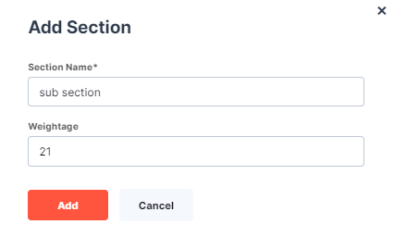

* **UC-1.5.3(k)**: Click on “**Add**”. The dialog box will disappear and the changed will be affected.
* **UC-1.5.3(l):** Click on **“Cancel”** the confirmation window will close without any making any changes.
* **UC-1.5.3(m):** Click on the “**Delete Section**” to remove an existing section.
* **UC-1.5.3(n):** The option will be deleted and will disappear.

**UC-1.6:** Actions

**UC-1.6.1:** In the Actions section, user can select various communication and interaction methods to be available for the form. The options include:

* Voice Call
* WhatsApp Call
* Recording
* SMS
* Email
* Click to Call
* GSM Gateway
* Audio Player
* Cloud Phone

**UC-1.6.2:** These options can be enabled by selecting the corresponding checkboxes.

**UC-1.6.3:** The enabled check boxes will be visible in customer profile.

**UC-1.6.4:** Click on “**Alchemy”.**

**UC-1.6.5:** Click on “**Call log Tab View**”.

**UC-1.6.6:** Select the “**Process”** and the “**Stage”** related to that

**UC-1.6.7:** Click on the “**Eye icon**”.

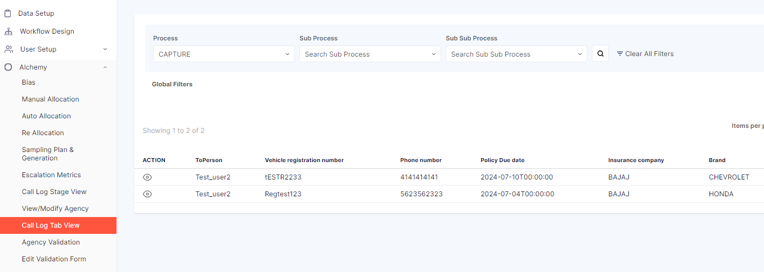

**UC-1.6.8:** A tab will open and the user can see customer profile page where user can see few icons

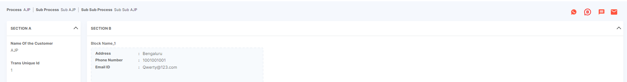

**UC-1.7:** Sections

* **UC-1.7.1: Section A**
  + **Scrollbar**: Toggle the scrollbar on or off for Section A.
    - if the toggle is on the scrollbar as a dropdown menu with (Horizontal, vertical, both) user can select any one option
  + **Minimized**: Toggle whether Section A is to be minimized.
* **UC-1.7.2: Section B**
  + **Scrollbar**: Toggle the scrollbar on or off for Section B.
    - if the toggle is on the scrollbar as a dropdown menu with (Horizontal, vertical, both) user can select any one option
  + **Minimized**: Toggle whether Section B is to be minimized.
* **UC-1.7.3: Section C**
  + **Scrollbar**: Toggle the scrollbar on or off for Section C.
    - if the toggle is on the scrollbar as a dropdown menu with (Horizontal, vertical, both) user can select any one option
* **UC-1.7.4:** Master Form
  + **Master Form**: Toggle the master form feature on or off.

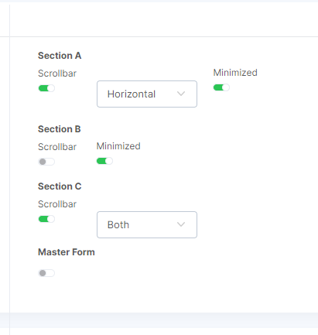

**UC-1.8**: Additional Action Options

**UC-1.8.1:** The additional options provide various features and requirements for the form, which can be enabled or disabled by toggling the switches. These include:

* Recording Required
* Evaluation Required
* Open Sample
* Show Audit Score
* Assigned To
* Allow Auto Fetch
* Allow Auto Fetch with Allocation
* Allow Question Movement
* Scheduler
* Enable Ticket Module
* Show Skip Audit
* Show Disposition
* Show SMS History
* Show WhatsApp History
* Show Email History
* Show Interaction History
* Show Stage History

**UC-1.8.2:** The enabled toggle buttons will be visible in customer profile.

**UC-1.8.3:** Click on “**Alchemy”.**

**UC-1.8.4:** Click on “**Call log Tab View**”.

**UC-1.8.5:** Select the “**Process”** and the “**Stage”** related to that

**UC-1.8.6:** Click on the “**Eye icon**”.



**UC-1.8.7:** A tab will open and the user can see customer profile page scroll down to find interaction history, Recording, SMS, WhatsApp, Email etc.

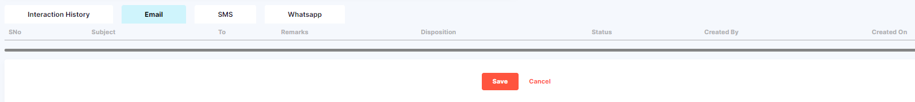

**UC-1.9:** Disposition

* Disposition Type
  + **AUTO**: Select this option for automatic disposition.
  + **MANUAL**: Select this option for manual disposition.
* Disposition Process
  + **WITHIN PROCESS**: Select this option for within process disposition.
  + **OUTSIDE PROCESS**: Select this option for outside process disposition.

**UC-1.9.1**: If “**AUTO**” is chosen

**UC-1.9.1(a):** Select"**WITHIN PROCESS**," a dropdown menu appears for selecting the stage.

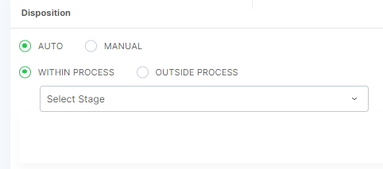

**UC-1.9.1(b):** If "**OUTSIDE PROCESS**," is selected

**UC-1.9.1(c):** Choose the **Process, Sub-Process, Sub-Sub-Process,** and **Stages** from their respective dropdown menus.

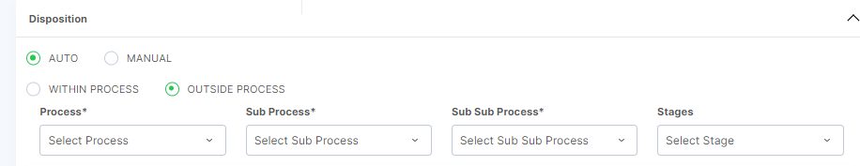

**UC-1.9.2:** If "**MANUAL**" is selected,

**UC-1.9.2**(a): "**ENABLE STAGE**" option becomes available. If activated

**UC-1.9.2**(b): Select "**WITHIN PROCESS**." Select stage option will come up

**UC-1.9.2**(c): Select desired Stage from the dropdown Menu.

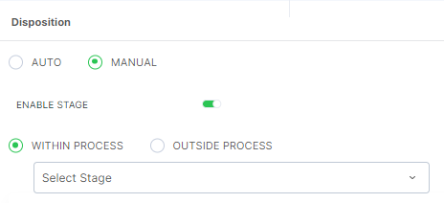

**UC-1.9.2(d):** Select **“OUTSIDE PROCESS”**

**UC-1.9.2(e):** Choose the **Process, Sub-Process, Sub-Sub-Process,** and **Stages** from their respective dropdown

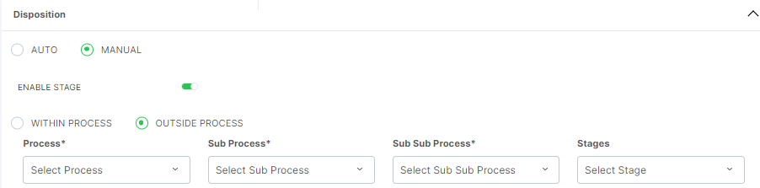

**UC-1.10**: Click the "**Save**" button to save the form.

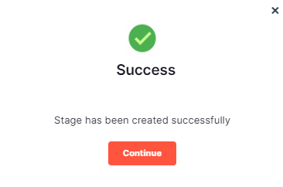

* A dialog box will appear with a success message

**UC-1.10.1**: If you want to cancel the changes, click on the “**Cancel”** button.

* The form will close without saving the changes.

**UC-1.10.2:** Close the Dialog box

* Click on the “**Continue”** button or “**Close”** (x) to close the dialog box.

**UC-1.11:** View Created Stage and Search

* **UC-1.11.1: Created Stage**: Once the Stage is created it will be displayed along with *Process*, *Sub Process*, *Sub Sub Process* and *Status*.
* **UC-1.11.2: Search any particular Stage**: If user has to search any particular Stage the user can search using the search bar.

